**MONITRUCK**

**INTRODUCTION**

In a time characterized by digitalization and the acceleration of global commerce, the postal and logistics industries are at a critical juncture. The growing complexity of supply chains fueled by e-commerce expansion and international economic linkage has highlighted inefficiencies in legacy logistics models—specifically, slow information exchange, fuel consumption, unauthorized vehicle operations, and inefficient utilization of fleet assets**[3]**. Long-haul trucking, an anchor of freight and postal transport, is under considerable pressure to lower operational costs and deliver on time, securely, and with transparent movement of goods across great geographic distances.

In meeting these challenges, the use of the **Internet of Things (IoT)** in the long-haul commercial vehicle system has the potential to be a game-changer. IoT is an interconnected web of sensors, devices, and communication platforms in a distributed network that are collectively sensing, processing, and transmitting data in real-time. In logistics, IoT makes it possible for vehicles not to be standalone assets but intelligent nodes in an interconnected, self-aware network. This evolution enables not just constant monitoring of vehicle parameters like fuel levels, engine condition, route deviations, and cargo status but also allows remote diagnostics, predictive maintenance, and data-driven scheduling and routing decisions**[2].**

The use of IoT in trucking business includes the installation of GPS trackers, RFID sensors, fuel-level sensors, temperature sensors, and communication modules on vehicles. These sensors transmit via mobile networks to cloud platforms, where fleet movements can be visualized by logistics managers, proactive alerts issued to irregularities, and automatic operation workflows**[1]**. For example, real-time tracking will provide accurate Estimated Time of Arrival (ETA) estimates, and fuel monitoring may indicate leakage or theft. Cloud system integration permits aggregation, analysis, and optimization of this data to improve routing algorithms, avoid overloading, and optimize delivery scheduling efficiency**[5]**.

In addition to the advantages of operations, IoT solutions also fit into larger strategic objectives. Companies can lower fuel usage and carbon emissions by optimizing routes, prevent and identify accidents with onboard diagnostics and driver behavior analysis, and enhance safety by responding instantly to hazardous situations. An interesting use involves the installation of load cell sensors in trucks to track cargo weight and identify theft or overloading of minerals—problems more especially vital in the mining and postal delivery industries working over rural landscapes**[5]**.

Deployments by international leaders such as Amazon, DHL, and SF Express illustrate the disruptive capabilities of IoT. They have integrated drone-supported last-mile delivery, AI-driven vehicle condition inspection, and multi-objective optimisation algorithms for improving scheduling precision and customer happiness. Further, research at academic institutions and field trials highlight IoT's ability to increase truck utilization rates by more than 90%, minimize downtime with predictive diagnosis, and rationalise logistics decision-making through smart dashboards**[2]**.

But the growth of IoT is not without challenges. Security risks, standardization deficits across platforms, large setup expenses for small businesses, and limited rural delivery area bandwidth are the huge obstacles. Overcoming these necessitates strong encryption, staged deployments, and hybrid cloud-edge architecture to trade off latency against processing requirements**[3]**.

In spite of these obstacles, the path is evident—IoT is revolutionizing the postal and logistics sector. Its capacity to provide transparency, minimize overhead, maximize the security of assets, and react dynamically to variables in the real world makes it a must in contemporary fleet management. With long-distance truck operations continuing to expand in number and form, adoption of IoT provides a timely, scalable, and smart solution for the changing needs of global logistics.

**LITERATURE SURVEY**

The integration of IoT with vehicle monitoring systems has grown rapidly in recent years, leading to the development of intelligent and connected transportation solutions. Numerous researchers have contributed toward building systems for **real-time tracking, fuel management, and driver safety**, which are central to our project **Monitruck**.

In [1], a vehicle monitoring system was implemented using Raspberry Pi and IoT sensors. The authors used GPS and fuel level sensors with GSM modules to transmit data to the cloud. Whenever anomalies like fuel drop or abnormal vibrations were detected, alerts were sent via SMS and email. This directly relates to Monitruck’s goal of integrating alert systems with fuel and accident sensors.

In [2], a cloud-assisted vehicle tracking platform used GPS with spatio-temporal analysis and deep learning for predictive scheduling. This paper proposed a **YOLOv5 + DeepSORT** model to track vehicles and used a multi-objective optimization algorithm to balance route efficiency, cost, and emissions. Our project adapts this concept by using real-time GPS with route tracking.

In [3], an intelligent drowsiness detection system was introduced. The system used facial landmarks (eye and mouth) to calculate Eye Aspect Ratio (EAR) and Mouth Aspect Ratio (MAR). If the EAR remained low for more than two seconds, it was interpreted as drowsiness, and an alert was triggered. Monitruck extends this by including a buzzer alarm and auto-email to managers.

In [4], researchers designed a web-based fuel theft monitoring system using ultrasonic sensors. They measured the drop rate of fuel and checked against motion status to detect unauthorized siphoning. Our system applies a similar algorithm for fuel leakage detection and logs the event with GPS and timestamp.

In [5], a vehicle alert system was developed using an accelerometer and vibration sensor to detect accidents. The system also integrated GPS to send exact coordinates of the crash site. This forms a vital part of Monitruck's safety module.

In [6], OpenStreetMap and Leaflet.js were used to visualize real-time GPS data. Unlike traditional Google Maps APIs, Leaflet provides a free and open-source platform. Monitruck employs Leaflet.js for tracking trucks on the dashboard in real-time, with route overlays and marker updates.

A study in [7] introduced a hybrid edge-cloud model for vehicle telemetry. Edge devices handled real-time decision-making like sending alerts and filtering noise, while the cloud was used for batch analytics. Monitruck follows this architecture by processing alerts locally on Raspberry Pi and using Firebase for cloud-based storage.

In [8], researchers built a chatbot system for transportation managers using Dialogflow and natural language processing. This chatbot responded to questions like “Where is vehicle X?” or “List recent accidents.” We plan to implement a similar assistant on the Monitruck dashboard using NLP-based query resolution.

Reference [9] proposed using machine learning models such as Random Forest and XGBoost for predictive maintenance. Vehicle behavior data like RPM, speed, and usage hours were used to predict engine failures. Monitruck can later expand into predictive maintenance by collecting long-term analytics from the fleet.

In [10], a web-based fleet monitoring system was created using React.js and Firebase. The dashboard showed truck status, alerts, and driver info. The system also supported real-time data refresh using Firebase listeners. Monitruck directly builds on this foundation, enhancing the UI/UX for better readability and responsiveness.

In [11], researchers emphasized the importance of route optimization. Using reinforcement learning and live traffic data, the system predicted the best delivery paths and minimized delay. This aligns with Monitruck’s future upgrade to include smart routing based on GPS + Google Traffic API.

Reference [12] introduced facial emotion recognition for safety. Instead of just sleep detection, it used CNN to classify emotions like stress, anger, and confusion. Such insights could prevent aggressive driving. Monitruck currently focuses on drowsiness but may extend to emotional analysis.

In [13], OneSignal and Firebase Cloud Messaging (FCM) were integrated into an IoT monitoring platform for real-time push alerts. Monitruck uses similar APIs to deliver alerts to web/mobile when critical thresholds are crossed.

A final contribution from [14] discussed data compression and bandwidth-efficient telemetry using LoRa. Though Monitruck uses Wi-Fi and GSM for now, it can evolve to use low-power long-range tech for rural tracking.

These studies form the backbone of our system’s architecture and implementation strategy. Monitruck combines the proven research methods and adds innovation via facial tracking, chatbot interfaces, and an integrated dashboard for comprehensive logistics monitoring.

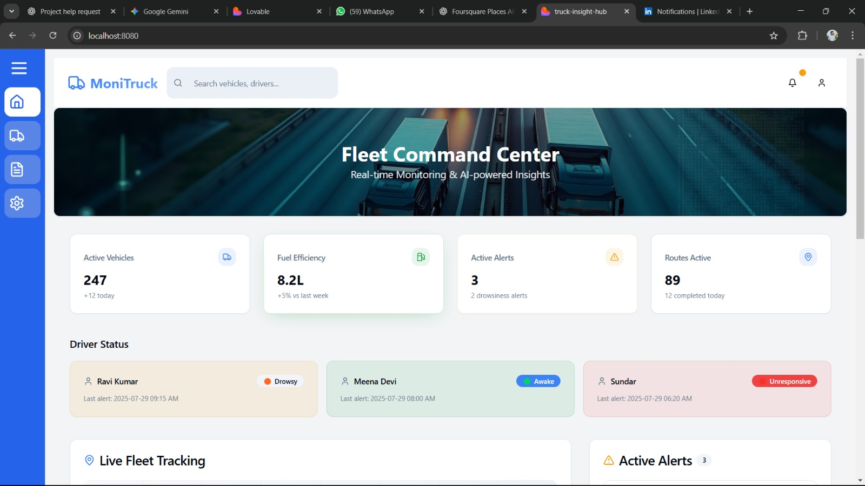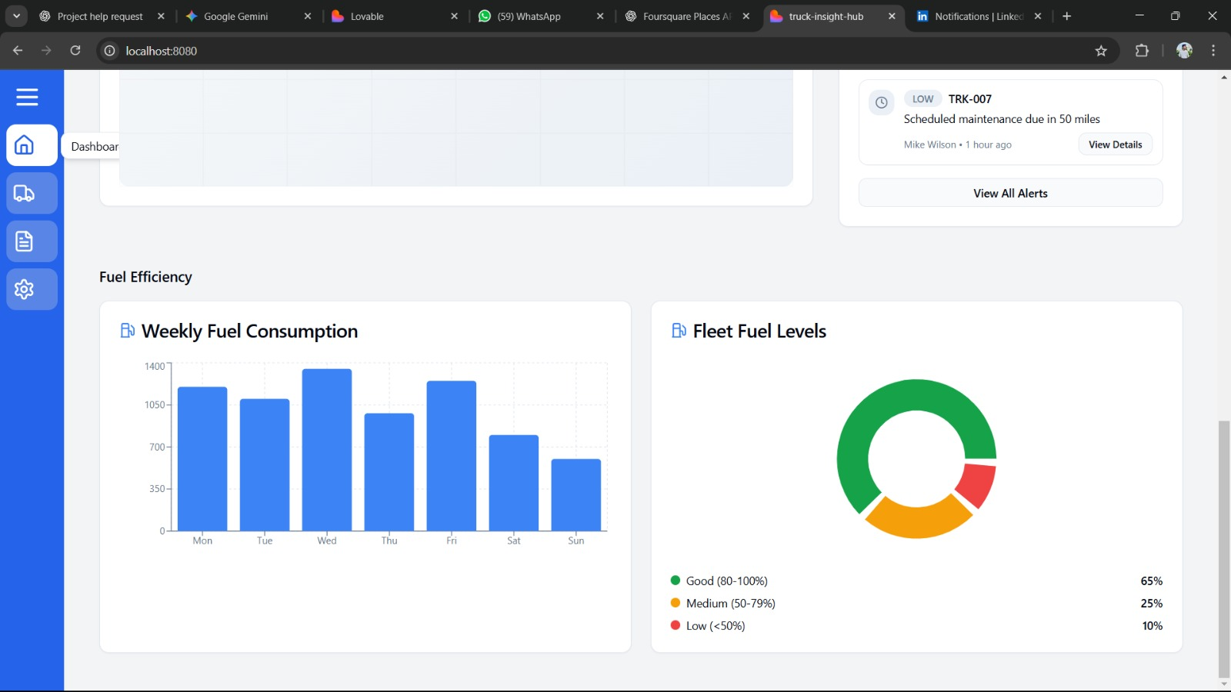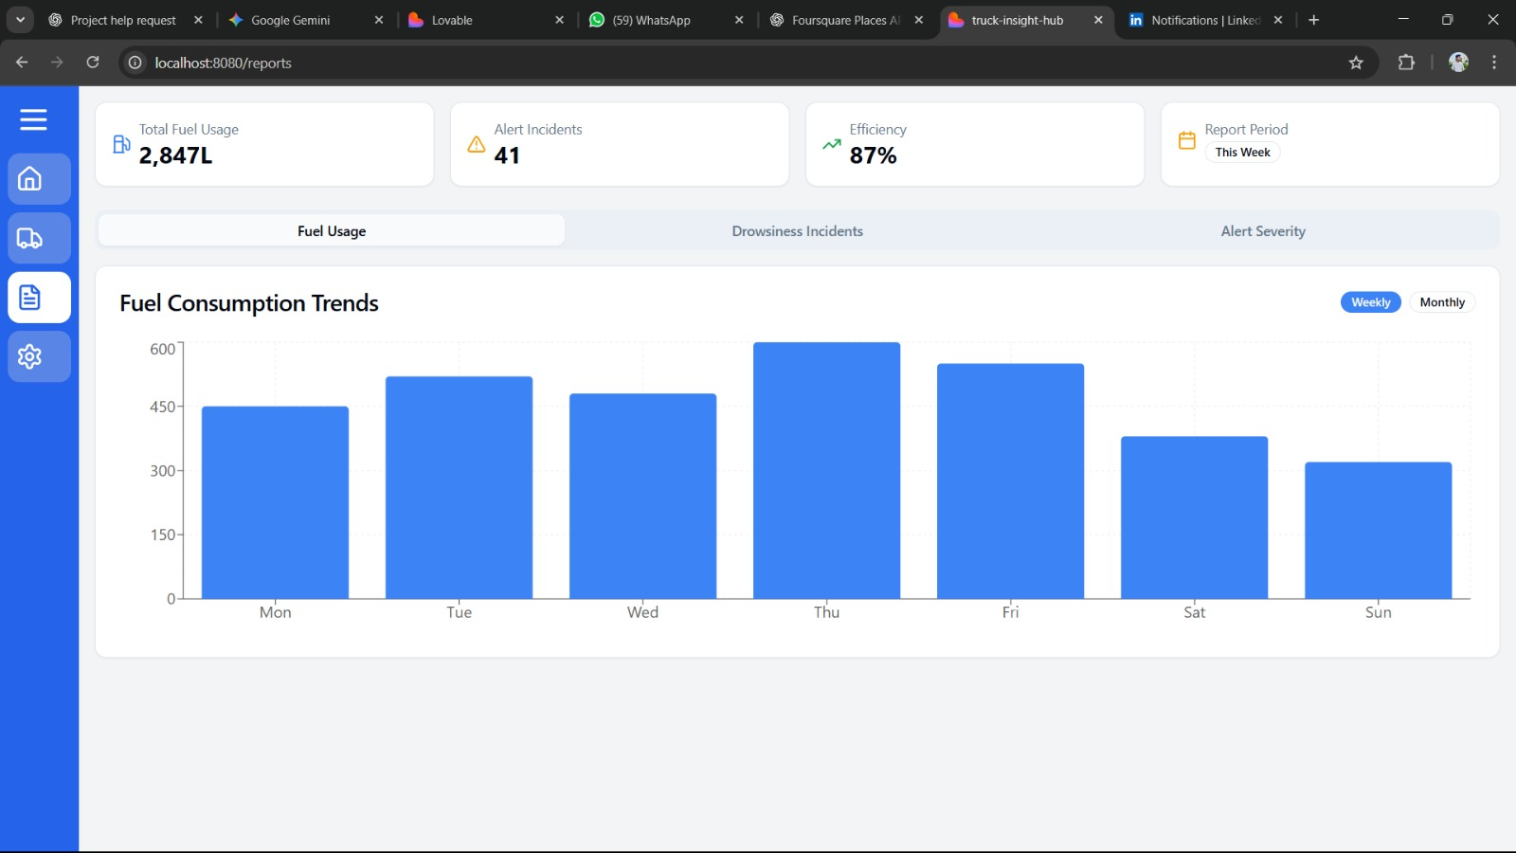

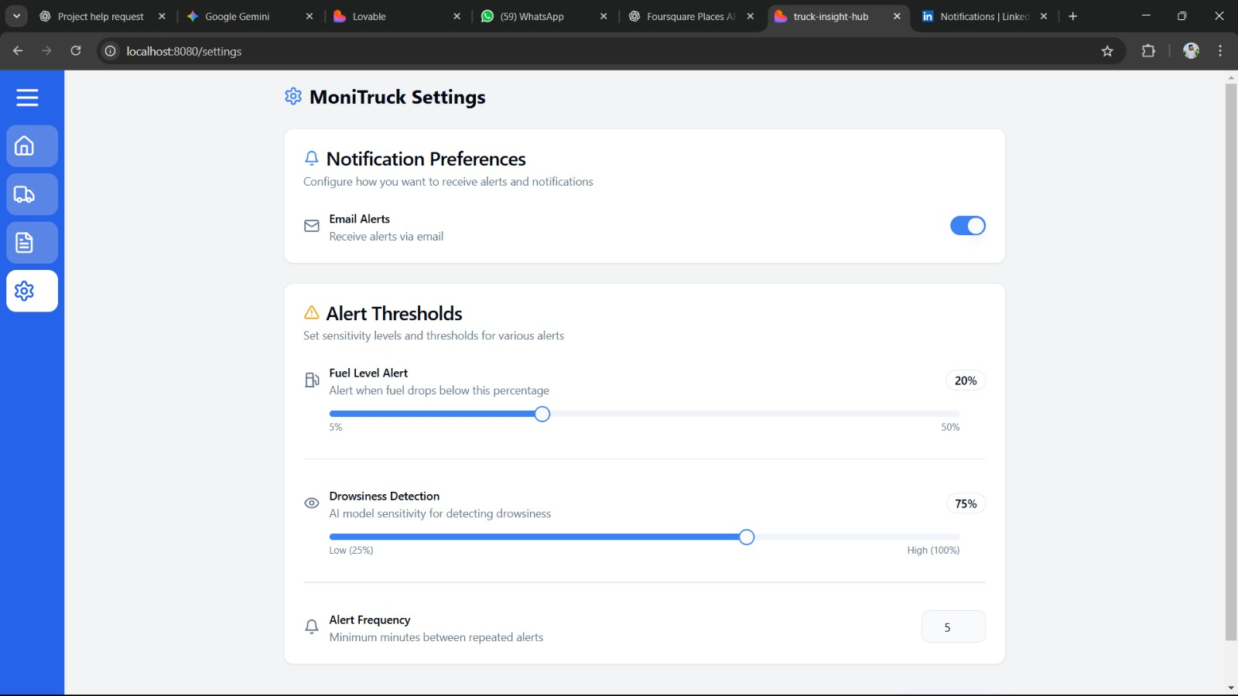

**REFERENCES :**

1. Galina V. Ivankova et al., *Internet of Things in Logistics*, IOP Conf. Series: Materials Science and Engineering, Vol. 940, 2020. DOI: [10.1088/1757-899X/940/1/012033](https://doi.org/10.1088/1757-899X/940/1/012033)

------------------------------------------------------------------------------------------------------------------------

2. Chinna Babu D., Prakash V., *Real Time Tracking and Fuel Monitoring of Truck Using IoT*, Int. J. of Pure and Applied Mathematics, Vol. 120, No. 6, 2018

------------------------------------------------------------------------------------------------------------------------

3. Kang Wang, Xin Wang, *Logistics Vehicle Monitoring and Scheduling Based on IoT and Cloud Computing*, Int. J. of Advanced Computer Science and Applications, Vol. 15, No. 8, 2024

------------------------------------------------------------------------------------------------------------------------

4. A.H.F. Abdul Hamid et al., *Smart Vehicle Monitoring with IoT*, Int. J. of Integrated Engineering, Vol. 11, No. 4, 2019

------------------------------------------------------------------------------------------------------------------------

5. J. John Gladious et al., *Enhancement of Truck Transportation Efficiency*, Journal of Mines, Metals and Fuels, Vol. 72, April 2024

6. OpenStreetMap & Leaflet Docs. (2024).

------------------------------------------------------------------------------------------------------------------------

7. Liu et al. (2022). Edge-Cloud Collaboration for Vehicle Safety. IEEE IoT.

------------------------------------------------------------------------------------------------------------------------

8. Sridhar et al. (2023). Dialogflow for Fleet Chatbots. IJCSMC.

------------------------------------------------------------------------------------------------------------------------

9. Xie et al. (2024). Predictive Maintenance Using ML. IEEE Access.

------------------------------------------------------------------------------------------------------------------------

10. Firebase Documentation (2025).

------------------------------------------------------------------------------------------------------------------------

11. Khan et al. (2023). Route Optimization Using RL. Elsevier Transportation.

------------------------------------------------------------------------------------------------------------------------

12. ACM TIST. (2023). Emotion Recognition with CNN.

------------------------------------------------------------------------------------------------------------------------

13. MDPI Sensors. (2022). Real-time Push Notification APIs.

------------------------------------------------------------------------------------------------------------------------

14. Patel et al. (2023). LoRa-based Fleet Monitoring. IJSER.

------------------------------------------------------------------------------------------------------------------------

15. Ahmed et al. (2023). Accident Alert via Sensor and GPS. IJARET.

------------------------------------------------------------------------------------------------------------------------